Flamingo Class Update 🦩Spring 2
Our Flamingo class have been busy, curious, and full of enthusiasm this term! Here’s a snapshot of our learning – we have loved being investigators, creators and learning about the wider world too…take a peek…
Languages, Literacy and Communication
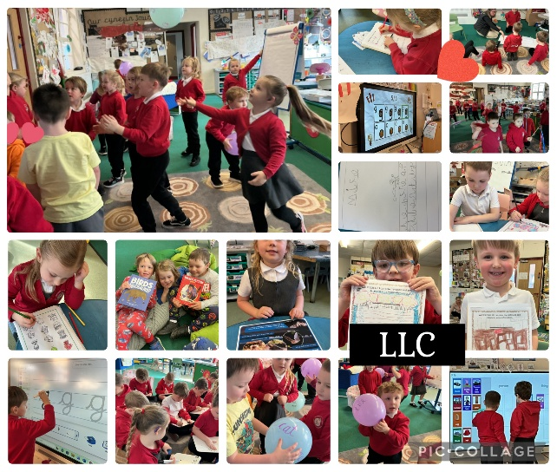
We have been developing our phonics skills daily, helping us become more confident readers and writers. The children are also working hard on their handwriting, focusing on correct letter formation and presentation. We love movement and have enjoyed ‘keepy uppies’ with the balloons and recognising sounds and tricky words. We have also loved ‘say the beat’ – it has tested both Mrs D and Miss S too! We’ve explored information writing, creating fact files about nocturnal, diurnal and crepuscular animals. The boys and girls have also worked hard on their presentation skills and were able to deliver some valuable knowledge in both our class assembly and during making our end of topic film!

Mathematics and Numeracy
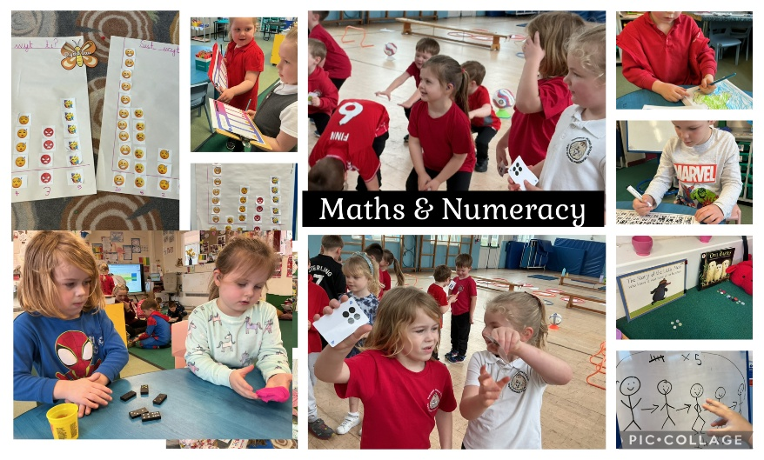
In maths, we’ve been exploring place value and building a strong understanding of numbers. We’ve been practising number bonds in fun and engaging ways, helping us become quicker and more confident. Our measurement work has included comparing lengths, weights and capacities. We even weighed our chicks! We also carried out a data collection activity to find out our favourite day of the week, which we presented using simple charts – can you guess our favourite day of the week? We have loved using our maths skills outside the classroom too – you will often see a PE warm-up game that is testing our maths skills!

Science and Technology
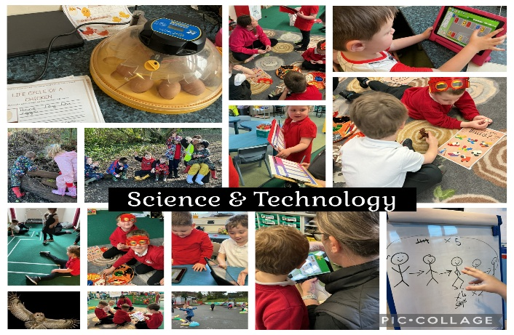
This term has been truly magical as we observed the lifecycle of a chick first hand. The children carefully watched the incubation process and took great responsibility in helping to look after our 12 fluffy chicks once they hatched. This hands-on experience sparked lots of questions and curiosity about living things and how they grow. We are so thankful to Will’s Farm for his fantastic support in this and to you our families for your kind donations towards the cost. We have worked hard also on our DCF skills and we have been looking at data handling – we asked simple questions and represented our data in a variety of ways. We also had a class pet (!) ‘Code-e-pillar’ we were able to give clear instructions so that he could find his way around our classroom! We also became robots ourselves and programmed our friends to navigate an obstacle course and to make something out of lego. Mrs D also became a robot and we had to direct her how to make a sandwich…it did not go well!! Mrs D buttered the bread packet…but only because we did not instruct her carefully! We then looked how to instruct a friend clearly!

Humanities
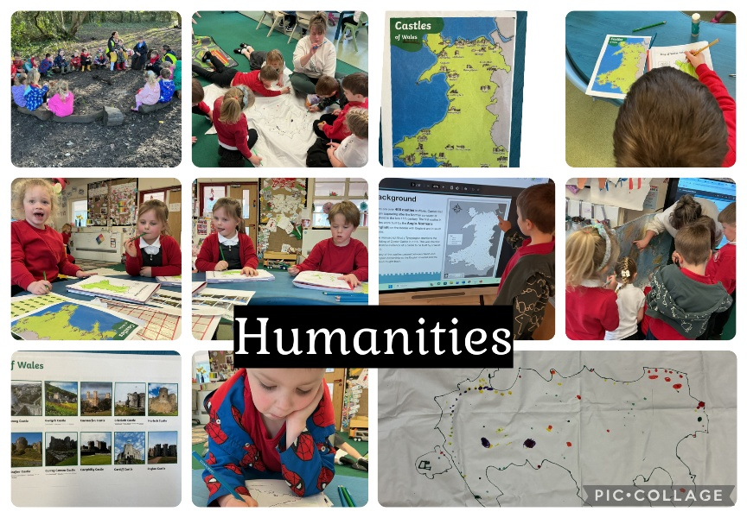
We explored castles in Wales and learned why they were built, linking our learning to simple map reading skills. The children enjoyed locating castles and developing their understanding of the world around them. We talked about the geography of a map and why they were built on top of a hill…did you know it is because ‘baddies get tired running up hills!’ We used our expressive arts skills to build a castle and Mrs D was the queen (of course!) we dressed up and explored different families that lived in our Welsh castles. We took time in our woodland to explore and we also spent time listening in the nature – it was lovely to hear Robins, Black Tipped Guls and Red Kites.

Expressive Arts
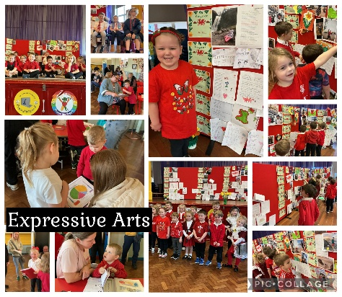
We proudly took part in our school Eisteddfod, celebrating creativity, performance and Welsh culture. In addition, we’ve been developing our dance skills in the gym, learning how to follow a simple “algorithm” (a set of instructions) to become coordinated and expressive dancers. We loved that so many of our families joined us in our sharing the learning – you are all so creative! We developed our knowledge of native Birds of Prey by painting them and making giant collages’ – we really did develop lots of textures, tones and lines.

Health and Well-being (HWB)
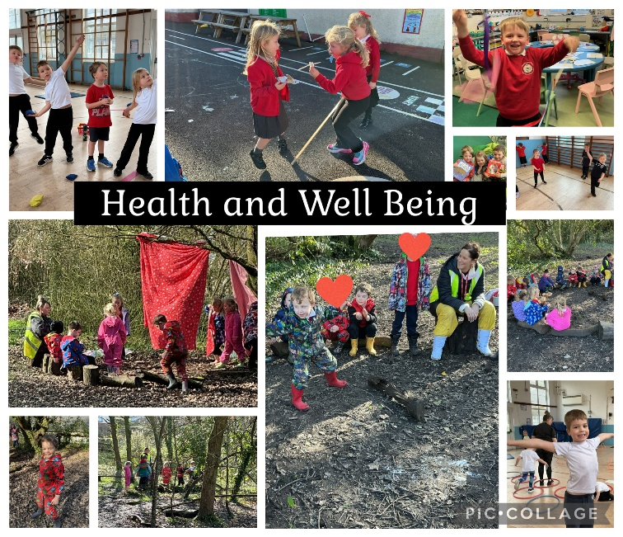
Staying active has been a big focus, particularly through dance in the gym. The children have been learning how to follow instructions, work together and build confidence in movement while keeping fit and having fun. We used the skills we learnt in our DCF lessons to have a PE ‘garden’ on how to programme a robot to dance – we observed to see what went well and then altered the dance accordingly! It was great fun. We used our outdoors to explore – we balanced, climbed a tree (only a little bit!) and had a performance of our own!

We are so proud of all the hard work and enthusiasm shown by Flamingo class this term. Diolch for your continued support!

