splendid skies
Home Learning Missions
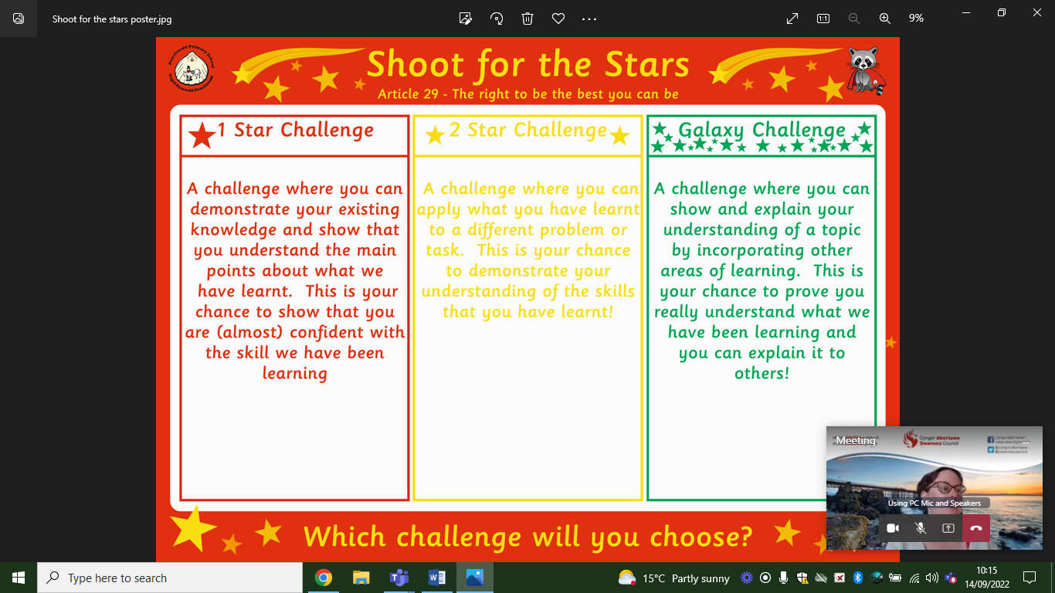
- Sky Spotter  Look up at the sky during the day or night.  Draw what you can see (sun, moon, clouds, stars).  - My House from Space  Imagine an astronaut looking down at your house.  Draw your house as it might look from space.  - Night Sky Walk  Go for a short walk with a grown-up.  Take a photo or draw something you noticed in the sky.  - Moon Watch  Look at the moon one evening.  Draw its shape and colour.  - People Who Help Space Travel  Draw someone who helps astronauts (e.g. scientist, engineer, astronaut). | - Sky Changes  Draw the sky in the morning and at night.  Can you write or tell an adult what is different?  - Design a Space Home  Draw a home for living in space.  Label what it is made from (glass, metal, solar panels).  - Vehicle Survey – Space Style  Draw different vehicles that travel on land, air and space.  Which one travels the furthest?  - Moon Facts  Draw the moon and write one or two facts about it.  - Space Helper Fact File  Choose a space helper and write a short sentence about what they do. | - My Home from Space  Draw a map of your area as if seen from space.  Add a key to show houses, roads or landmarks.  - Eco Space Home  Design a space home that helps protect Earth.  Label materials and explain why you chose them.  - Sky Investigation  Observe the sky over three days.  Draw or record how it changes.  - Interview a Star Gazer  Ask an adult questions about the sky or space.  Record answers using writing, pictures or a short video.  - Create a Space Guide  Make a leaflet or mini-book called “Splendid Skies”.  Include drawings and facts about the sun, moon or stars.

